HR Diversity Dashboard Report

Prepared by: Simisola Adamo
Date: 02/16/2024

Business Challenge the Human Resources (HR) department seeks insights and analysis regarding employee diversity and workforce composition for the year 2018. This analysis aims to highlight key workforce demographics and identify areas for potential improvement in diversity and inclusion.
Goal Develop an interactive and insightful dashboard to visualize employee data and provide key HR metrics to support strategic decision-making.
Objectives
- Provide insights into the company's overall workforce diversity in 2018.
- Analyze gender diversity across different business units (BUs) and employment types (Full-Time vs. Part-Time).
- Evaluate the distribution of active employees by ethnicity.
- Present the age range distribution of active employees.
- Identify potential areas for improving diversity and inclusivity.
Key Steps
- Develop mock-up questions and dashboard layout.
- Determine the male-to-female employee ratio.
- Assess gender diversity distribution across BU regions and employment types (FT vs. PT).
- Analyze the ratio of FT vs. PT employees.
- Examine the distribution of employees by age range.
- Quantify the number of employees by ethnic group.
- Calculate the average tenure days per BU region for each employment type.

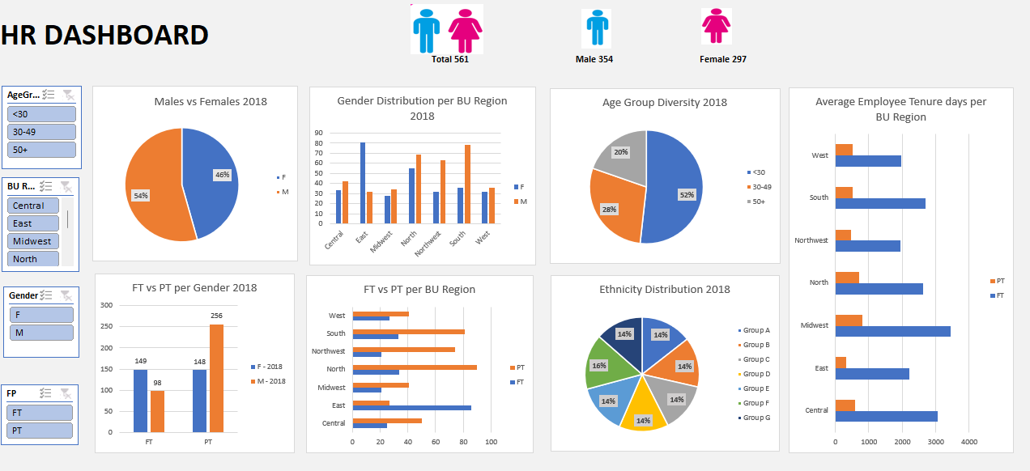

Business Insights
- In 2018, the organization employed more males (354) than females (297).
- Employees aged under 30 (337) outnumbered those in the 30-49 and 50+ age groups combined (314).
- The company had significantly more part-time employees (404) than full-time employees (247).
- Among part-time employees, 108 more males were employed than females. However, the trend reversed for full-time employees, with 149 females versus 98 males.
- All BU regions had more part-time employees than full-time, except for the East, which had 86 full-time vs. 27 part-time employees.
- Ethnic representation was relatively even, with Group F being the highest (102) and Groups C and D being the lowest (91).
- Gender distribution varied by BU region:
  - The Eastern BU had more than twice as many females as males.
  - The Southern BU had nearly twice as many males as females.
  - The Midwest and West regions exhibited relatively balanced gender distributions.
- The Midwest had the highest average employee tenure:
  - Full-Time: 3,454.14 days
  - Part-Time: 805.71 days
- The lowest average tenure was observed in:
  - Full-Time: Northwest (1,946.90 days)
  - Part-Time: East (320.04 days)

